**PROPOSAL for**

**NDI SERVICE for**

**Royal Securities Exchange of Bhutan.**

**Document Control**

**Document Information**

|  | **Information** |
| --- | --- |
| Document Id | ***NDI-RSEBL*** |
| Document Owner | *NDI* |
| Issue Date | *11 November 2023* |
| File Name | ***PROPOSAL for NDI SERVICE to Royal Securities Exchange of Bhutan(RSEBL)*** |

**Document History**

| **Version** | **Issue Date** | **Changes** |
| --- | --- | --- |
| *[1.0]* | *11/11/23* | *First Draft* |

**Document Approvals**

| **Role** | **Name©** | **Signature** | **Date** |
| --- | --- | --- | --- |
| Project Sponsor | Jacques von Benecke |  |  |
| Project Review Group | Anand Acharya |  |  |
| Project Review Group | Tshendu Gyeltshen |  |  |
| Project Manager© | Suprit Pradhan |  |  |
| Project Manager  *client* |  |  |  |
| Communications Manager | Pallavi Sharma |  |  |

**Table of Contents**

**1 Background 3**

1.1 History 3

1.2 Requirements 3

1.3 Solution 4

**2 Proposal 5**

2.1 Vision 6

2.3 Deliverables 8

2.4 Timeframe 9

2.5 Resources 10

2.6 Ownership 11

2.7 Success Criteria 12

2.8 Authorization 12

# **Background**

## **History**

The National Digital Identity Project (NDI) is one of the digital transformation projects under the umbrella of Digital Drukyul. The project aims to deliver a seamless and secure digital platform to enable citizens and residents to identify and authenticate themselves in the digital world. Through the platform, users will be able to share verifiable credentials (digital credentials) with different organizations/individuals. The project is being implemented by DHI.

To deliver state of the art digital identity for individuals, businesses, and public services of Bhutan, it was recognized that a robust and cutting-edge solution had to be implemented. This would not only help overcome the domestic challenges in the digital ecosystem but also bring the nation on an equal playing field in the international arena.

The NDI project has adopted the philosophy of Self Sovereign Identity (SSI), with a cutting-edge technology using Decentralized Identifiers (DID). Many countries have recognized the value of Decentralized Identity and have implemented it in different industrial and business sectors. Bhutan looks toward being the first sovereign nation to adopt SSI-based digital identity at a national level.

## **Requirements**

The policies, regulations, and tools for addressing the identity issues in the digital ecosystem, handling private data, and preserving individual privacy are currently at a nascent stage of development. And many of these requirements are being developed in silos, hindering its interoperability internationally. The NDI project will not only provide a robust solution but also act as a catalyst for awareness, adoption, and maturity of best practices, standards and technology for digital identity and related services in the country.

The conventional practice of sharing hardcopies of Identity documents (eg. CID, birth Credentials) to any public or private service providers exposes PII (Personally Identifiable Information) of the customers more than what is required. This is because there may not have been any other convenient and quick way for service providers to get the validated information that they require. Therefore, both service providers as well as the consumers tend to be more complacent in terms of privacy and confidentiality. As a result, such practices have deep-rooted itself in business practices, in both public and private sectors.

However, with growing adoption of technology and automation, the associated risks have escalated for both public and service providers. Additionally, there’s a need for service providers to comply with international standards and norms of interoperability and acceptance. As the intricacies of digital services and their integrations grow for convenience, the impact and consequences of identity breach become highly risky and far-reaching.

The NDI project aims to address these concerns and provides the tool and capabilities to service consumers and providers, enabling disclosure of minimal personally identifiable information (PII) while establishing trust in their digital transactions. NDI, under the guidance of the Government, aims to help install best practices in the digital ecosystem which would require business process re-engineering in areas that require PII sharing and identity verification and authentication.

**Business Problem**

Currently, accessing RSEB-mCaMS-Access and RSEBL client services through the m-CaMS app requires the use of login credentials (username and password). Managing and remembering these credentials can be challenging, particularly when dealing with multiple sets of login information. As a result, the login process can be time-consuming and effort-intensive when attempting to access the system for service availability.

**Business opportunity**

Leveraging NDI, RSEBL has significant potential to enhance service delivery and internal systems management, unlocking new opportunities by rapidly retrieving customer information within seconds with customer consent for eKYC. The exchange of Verifiable Credentials (VC) further amplifies these possibilities.

Among the various areas where NDI can benefit RSEBL, the identified use case for the PILOT 1 phase in the RSEBL m-CaMS application and "RSEB-m-Cams -Access" portal in implementing a passwordless login system using NDI. With the Bhutan NDI, multiple users can conveniently access the system by scanning a barcode or using a deep link, providing instant access to services.

To make the password less login efficient, a login VC will be issued to users in their Bhutan NDI wallet.Thus as per their login VC the users can login using Bhutan NDI.

## **1.3 Solution**

At the core of the NDI solution, there are three parties:

1. **Issuer** - (an organization or individual integrated with NDI) who issues Verifiable Credentials (eg. Foundational ID, Security Clearance, Work Permit, Employment Details, Bank Account details, etc.)
2. **Holder** - (an individual) who has Bhutan NDI app (digital wallet) in their smartphone. The user can use the wallet to create a secure connection with Issuers and verifiers and can receive verifiable credentials from issuers and share the credentials as proof when required.
3. **Verifier** - any party who requires proof or validated PII information from an individual. After integrating with NDI, it can directly request proof from an individual from their wallet. (An entity can be both issuer and verifier, i.e., Bank asking for information to open a bank account-verifier role, then opening the bank account and sending the Holder a verified credential with the bank account details-Issuer role)

The SSI philosophy, technology and solution architecture was presented and discussed in detail with the BTI during the previous many meetings.

**Use case 1 : Issuance of login credential through RSEB-m-CaMS .**

In order to access the systems, users must possess login credentials. Therefore, within the RSEB-m-CaMS protal , a dedicated option will be available for users to request Verified Credentials (VC). Upon submitting the necessary proof to RSEB, users can anticipate receiving their credentials directly on their digital wallet.

This streamlined process ensures a secure and efficient method for users to obtain the necessary access to the systems.

**Use Case 2 and 3 : Passwordless Login using Bhutan NDI**

To access the system, users are given the option for the "Login with Bhutan NDI '' feature in both m-CaMS application and “RSEB-m-Cams -Access" portal and then proceed to scan the provided barcode or utilize a deep link if they are using the same device. It is imperative that users have already completed the registration process with Bhutan NDI before they can avail themselves of the services.

Throughout the login procedure, users are required to share their verified credentials to the RSEBL. Following the verification of these credentials by the RSEBL, access to the system will be granted.

**Scope**

For this phase, only the specified use case of passwordless login and issuance of login credentail will be addressed. The solution will adhere to the SSI philosophy and governance requirements of NDI, ensuring full automation.

During integration, the NDI team will provide RSEB with required APIs and access tokens. Client services like verifier, issuance, and agent service will be deployed in NDI AWS.

RSEB has the flexibility to host services on their premises or on NDI-managed AWS. NDI offers assistance and Customization of the NDI client service throughout integration.

To consume APIs, RSEB needs to take necessary actions and adjust their "RSEB-m-Cams-Access" protal and M-CaMS for data consumption.

For use case 1, RSEB is set to introduce an additional feature in their portal labeled "Get Login Credential." Once users select this option, it will trigger the issuance of a verified credential, promptly delivered to their digital wallet. This enhancement aims to simplify and expedite the process, offering users a straightforward means of acquiring their login credentials securely through the application.

For the use case 2 and 3 integration RSEB needs to add an additional option : Login with BhutanNDI” in their respective application the button design shall be provided to RSEBL by NDI.

Thus after selecting any option in use case 1-3 it will initiate the future integration.

Foundational data that can be consumed by RSEBL from NDI wallet are as reflect below :

| **Credential** | **Attributes** |
| --- | --- |
| Foundational ID | Household No, Date of Birth , Citizenship,ID Type,ID No,Full Name,Gender. |
| Permanent Address | Thram No,Village,Gewog,Dzongkha,House No. |
| Self Attested | Allergy, Mobile no ,email,Current Address. |

# **Proposal**

# 

Currently, RSEBL customers access the m-CaMS app/"RSEB-m-Cams -Access" portal by entering their username and password to request services. In the upcoming phase, we plan to implement a passwordless login feature using the Bhutan NDI. Users will be able to log in by scanning a QR code or utilizing a deep link, providing a more streamlined and secure authentication process.

## **Vision**

"To optimize and streamline the user authentication journey, creating a frictionless and intuitive login experience that prioritizes efficiency and security through Bhutan NDI."

* 1. **Goals:**

Strive to enhance the overall customer experience by providing a quick and hassle-free access to services, fostering trust, and ensuring the privacy and security of user information

**Solution Design**

Below is the diagram illustrating the layers of interaction within the NDI and RSEBL ecosystems.

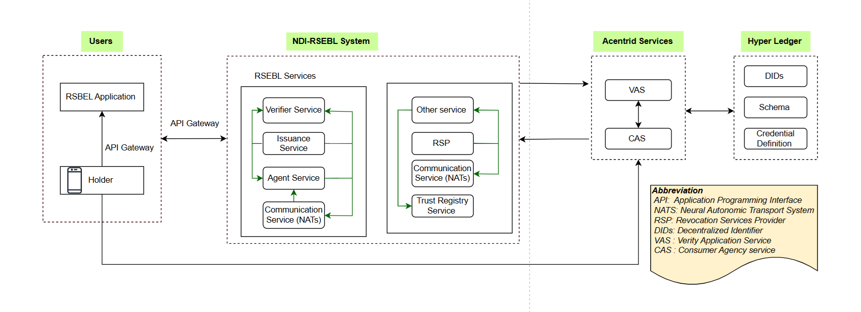

[Sequence Diagram-NDI-RSBEL Ecosystem .drawio.png](https://drive.google.com/file/d/18P4Bqp5BswgRTrbWRPRR_sAQSWbGBVXr/view?usp=drive_link)

*Fig 1. NDI-RSEBL flow .*

A sequence diagram of login VC issuance between the different actors and systems in the process are depicted as below**.**

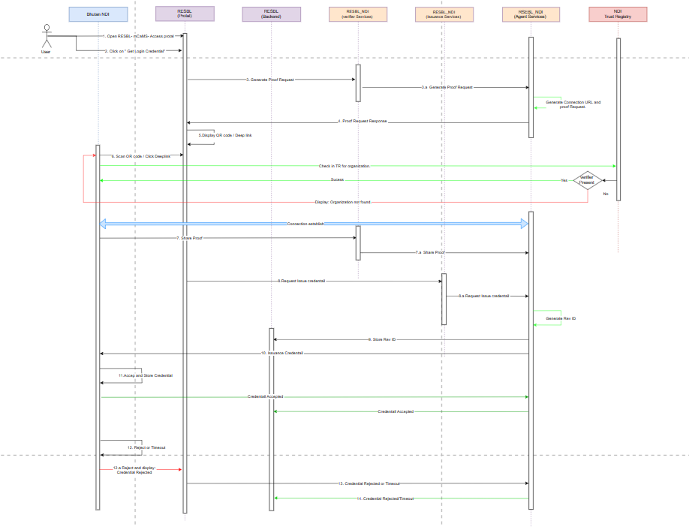

[Sequence Diagram-Issunace of VCs.drawio.png](https://drive.google.com/file/d/1K6yedU27YM3GLJ3QtX_RtOu2NBWVGcAv/view?usp=drive_link)

*Fig 2. Issuance of login VC*

A sequence diagram of passwordless login between the different actors and systems in the process are depicted as below**.**

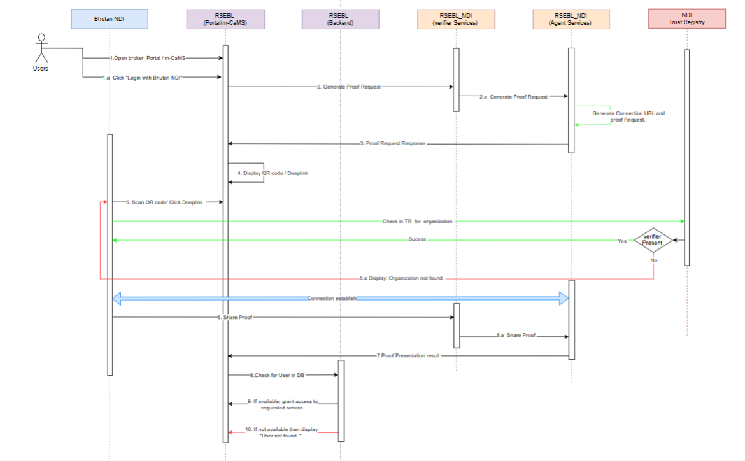

*Fig 3. Passwordless login .*

**Proof Template**

The proposed proof template that RSEBL will ask from the NDI wallet of the users for the mentioned use cases:

**Use Case 1: Issuance of login VC**

**Proof to share:**

| **Attribute** | **Type** | **Source Schema** | **Restriction** | **Remarks** |
| --- | --- | --- | --- | --- |
| ID type | String |  |  |  |
| CID Number | Alphanumeric | Foundational ID VC | Only issued from DCRC/DOI |  |

**VC Attribute received:**

| **Name** | **Format** |
| --- | --- |
| Username | Number |
| Role ID | Number |
| Validity | Datetime |
| Revocable | Yes |

**Use Case 2: Passwordless Login using Bhutan NDI for "RSEB-m-Cams -Access" Application.**

**Proof to share from Bhutan NDI:**

| **Attribute** | **Type** | **Source Schema** | **Restriction** | **Remarks** |
| --- | --- | --- | --- | --- |
| Username | Alphanumeric | RSEB VC | Only issued from RSEB |  |
| Role ID | Number | RSEB VC | Only issued from RSEB |  |

**Use Case 3: Passwordless Login using Bhutan NDI for m-CaMS**

| **Attribute** | **Type** | **Source Schema** | **Restriction** | **Remarks** |
| --- | --- | --- | --- | --- |
| Username | Alphanumeric | RSEB VC | Only issued from RSEB |  |
| Role ID | Number | RSEB VC | Only issued from RSEB |  |

**Verifiable Credential (VC) Schema**

The attributes of the planned use case schema are as given in the table below. RSEB will issue the credential to its users based on this template. However, this is not a fixed template, as the NDI ecosystem matures, RSEB can adopt the most used and popular *Schemas* to issue credentials to its users.

**Use Case 1: Schema of Issuance of login VC**

| **Attribute** | **Type** | **Remarks** |
| --- | --- | --- |
| Username | Number |  |
| Role ID | Number |  |
| Validity | Datetime |  |
| Revocable | Boolean | Credential can be revoked |

## **Deliverables**

BTL will be Verified (Customer details for registration). For onboarding BTL onto NDI ecosystem, the following are the deliverables of this collaboration:

| **Project Deliverables** | | |
| --- | --- | --- |
| **Title** | **Description** | **Notes** |
| NDI-RSEBLLServices | Set of NDI Client Services that will provide Verification service to all internal RSEBL Systems. | NDI-RSEBL is a working name, and a proper name will be coined at a later stage. These NDI specific services can be deployed at RSEBL premises. NDI also offers to deploy at AWS and maintain the uptime. |
| BhutanNDI App (wallet) | Digital wallet that the end user (customers) will use to hold and share Verifiable Credentials (VC). | This is not a direct deliverable to RSEBL, but the end users will use this wallet for all other use cases as well. |
| RSEBL Backend Service | The RSEBL Backend Service consists of API’s responsible for fetching and integration with NDI. |  |
| RSEBL Frontend App (Portal) | The portal will take care of the user interfaces that will be interacted with by the users. |  |

## **Timeframe**

The onboarding and integration of RSEBL with NDI Services will have to be completed for the Pilot 1 Launch. An estimate high-level project tasks and timelines are as follow:

| **Number** | **Task Name** | **Status** | **Remarks** |
| --- | --- | --- | --- |
| 1 | Confirm Use Case | Complete |  |
| 2 | Appoint Project Team | Complete |  |
| 3 | Resource Plan | Complete |  |
| 4 | Technical Feasibility |  |  |
| 5 | Build Deliverables |  |  |
| 6 | Testing |  |  |
| 7 | Quality Plan |  |  |
| 8 | Risk Plan |  |  |
| 9 | Perform Project Closure |  |  |

## **Resources**

There are two options to deploy the client setup.

**1.On Premises**

The resources required from organization for deployment of NDI- RSEBL System is:

**Server Host - 1 Number (Production Environment)**

* *Public IP Address*
* *Processor 2 core*
* *RAM 16GB*
* *Storage 500GB - 1TB*
* *OS Ubuntu*

**Server Host - 1 Number (Testing/Staging Environment)**

* *Public IP Address*
* *Processor 2 core*
* *RAM 16GB*
* *Storage 500GB*
* *OS Ubuntu*

AWS related services required for on premise servers.

|  | Costing | Costing |
| --- | --- | --- |
| AWS Cognito - used for user authentication services | Free for first 50,000 active monthly users | $0.0055 for 1 active user per month after crossing 50,000 users. That is, from 50,001 to 100,000 |
| AWS Application Load Balancer |  | $17.4/month |

**2.On cloud:**

Where this service is deployed on cloud. The cloud provider that NDI currently uses is Amazon Cloud service.

The following set up will be provided if the organization chooses to go with cloud deployment.

| **AWS service** | **No. of services** | **Cost per month** |
| --- | --- | --- |
| EC2 - m6g.xlarge | 1 no. | $80.41 |
| Load balancer | 1 no. | $18.40 |
| Route 53 | 1 no. | $1 |
| Cognito | 100 MAUs | $5 |
| AWS Secret Manager | 20 nos. | $10 |
|  | **Total** | **$114.81** |

**MAUs** - You pay for Amazon Cognito user pools based on your monthly active users (MAUs). A user is counted as a MAU if, within a calendar month, there is an identity operation related to that user, such as sign-up, sign-in, token refresh, password change, or a user account attribute is updated. You are not charged for subsequent sessions or for inactive users within that calendar month.

**m6g.xlarge** consists of the following Specification:

1. vCPU : 4
2. Memory (GiB) : 16
3. Instance Storage (GB) : EBS 100GB
4. Network Bandwidth (Gbps)*** : Up to 10

(These services will be deployed on the AWS under the root account of DHI in Bhutan OU. Admin access will remain with the DHI’s focal person/administrator who will be managing the services.)

The total monthly cost of operating the environment in the AWS Estimated to be around $100/month.This is an estimated expense and will increase as services added up.

## **Ownership**

| **Project Ownership** | | |
| --- | --- | --- |
|  | | |
| **Role** | **Name** | **Contact Details** |
| Project Sponsor  *[responsible for delivery of the project. The Project Manager reports to him.]* | Jacques von Benecke  CTO, DHI | [jacques@dhi.bt](mailto:jacques@dhi.bt) |
| Project Manager  *[from NDI]* | [Suprit Pradhan](mailto:supritpradhan@dhi.bt)  PM, NDI | [supritpradhan@dhi.bt](mailto:supritpradhan@dhi.bt) |
| Product Owner  [from NDI] | Anand Acharya  Product Manager, NDI | [anadacharya@dhi.bt](mailto:anadacharya@dhi.bt) |
| NDI Focal Person and Backend Developer  [from NDI] | [Tshendu Gyeltshen](mailto:tshendugyeltshen@dhi.bt),Sangay Rinchen |  |
| Network/Infrastructure Focal Person (from NDI) | Chimi |  |
| RSEBL Focal Person |  |  |

## **Success Criteria**

* Project is delivered on time and the level of quality expected.
* Successfully onboarding of customers.

## **Authorization**

This is the section in which your Project Sponsor will authorize the project if they want it to be initiated. If the project is authorized, then you have done a great job in completing this Project Proposal!

| **Project Sponsor**    *Name:*  *Position:*  *Date: __ / __ / __* | **Customer**    *Name:*  *Position:*  *Date: __ / __ / __* |  |
| --- | --- | --- |